Paper 1

1 | 2 | 3 | 4 | 5 | 6 | 7 | 8 | 9 | 10 | 11 | 12 | 13 | 14 | 15
C | A | C | C | D | B | A | B | B | D | B | A | C | A | A
16 | 17 | 18 | 19 | 20 | 21 | 22 | 23 | 24 | 25 | 26 | 27 | 28 | 29 | 30
C | C | C | A | C | A | C | D | B | B | B | B | D | C | A

Paper 2

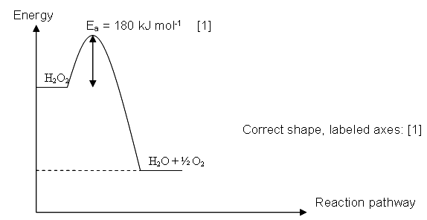
1(a) (i)

(ii) ΔH = 180 – 282 = -102 kJ mol⁻¹

(iii) The activation energy will decrease.

- ΔH = 150 – ½ (496) = -98 kJ mol⁻¹

(v) Bond energy is an estimated value / average value only.

(b) (i) Amount of unreacted iodine = 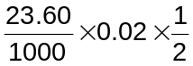
= 2.36 x 10⁻⁴ mol

- Amount of iodine reacted with sulfur dioxide = 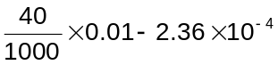
= 1.64 x 10⁻⁴ mol

- I₂ +2e → 2I⁻
SO₂ + 2H₂O → SO₄²⁻ + 4H⁺ + 2e
Balanced equation: SO₂ + I₂ + 2H₂O → 2I⁻ + SO₄²⁻ + 4H⁺

Amount of SO₂ present in wine = 1.64 x 10⁻⁴ mol

- Concentration of SO₂ = 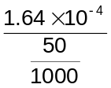 = 3.28 x 10⁻³ mol dm⁻³
[Total: 12]

2(a) (i) The first ionisation energy of an element is defined as the amount of energy required to remove one electron from each atom in a mole of gaseous atoms producing one mole of gaseous ions with one positive charge.

(ii) Be(g) → Be⁺(g) + e

(b) N 1s² 2s² 2p_{x}¹2p_{y}¹2p_{z}¹ O 1s² 2s² 2p_{x}²2p_{y}¹2p_{z}¹
Less energy is required to remove a paired 2p electron in O since repulsion is experienced between the paired electrons.

Ionisation energy / arbitrary units
Ionisation number
(c)
1 2 3 4 5 6

- (i) SiO₂ is giant covalent that requires a lot of energy to break the strong covalent bonds between atoms during melting.

SiCl₄ is simple covalent that requires little energy to break the weak Van der Waals’ forces between molecules during melting.

  - SiCl₄ + 2H₂O → SiO₂ + 4HCl
pH = 2 (3 is also accepted)
[Total: 10]

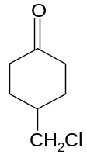
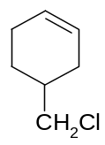
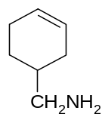
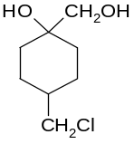
3(a)
A
B
C
D

(ecf from B)

E: HCN, trace amount of NaOH, (10 – 20 ºC)

F: HCl (aq), reflux

(b) Test: Add Tollen’s reagent to J, K and L and warm.
Observation: Only Y gives silver precipitate, the others will not.
OR Add 2,4-DNPH and warm, only Y gives orange precipitate, the others will not.

Test: Add Br₂ in CCl₄ or aqueous to J and L.
Observation: Only J decolourises the reddish-brown Br₂. L will not.

Test: Add I₂, NaOH (aq) and warm L.
Observation: L gives yellow precipitate
OR Add PCl₅ to L, white fumes (HCl) is evolved.
Answers of the correct logic or sequence will be given marks.

(c)
Acidified KMnO₄,

Reflux
[1]
Cl₂,
AlCl₃

[1]

CH₃
CO₂H
CO₂H
Cl

[1]

[Total: 12]

4(a) The sailors ate fruits / vegetables.

(b)

OR

(c) Starch

(d) Amt of triiodide solution = Amt of vit C in 25.0 cm³ sample = 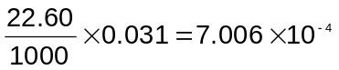
Amt of vit C in 100 cm³ sample = 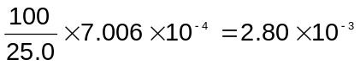

Mass of vit C in tablet =

Common dose of vitamin C is likely to be 500 mg.

[Total: 6]
5(a) (i) It is the enthalpy change when one mole of water is formed in the neutralisation of an acid and alkali, the reaction being carried out in aqueous solution under standard conditions, at 25 ºC, 1 atm.

- Amt of CH₃CO₂H = 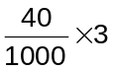 = 0.012 mol
Amt of KOH = 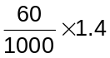 = 0.084 mol (limiting) = Amt of H₂O formed = 0.084 mol
Heat absorbed by water = (40 + 60) x 4.2 x 10.5 = 4410 J
ΔH_{n} = -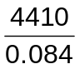= - 52500 J mol⁻¹ = -52.5 kJ mol⁻¹

- The value in a(ii) is less exothermic/ less negative/ differs from that of the reaction between a strong acid and alkali because the enthalpy change due to the conversion of CH₃CO₂H into ions has to be considered.

(b) (i) Le Chatelier's Principle states that if a change is made to a system in equilibrium, the system reacts in such a way as to tend to oppose the change, and a new equilibrium is formed.

(ii) Low temperature, so that equilibrium will lie to the left which is the backward exothermic reaction.
Good air flow, so that equilibrium will lie to the left to decrease the amount of oxygen gas.

(iii) There will be an increase in the production of SO₃.
Equilibrium will lie to the right to decrease the amount of oxygen gas when there is good air flow and the low temperature favours the forward exothermic reaction.

(iv) K_{c} = 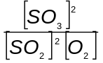

(v) 2SO₂(g) + O₂(g) 2SO₃(g)
I 2 1 0
C -1.9 -0.95 +1.9
E 0.1 0.05 1.9
Equilibrium concentration of SO₂ = 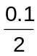 = 0.05 mol dm⁻³ (Recall vol is 2 dm³.)
Equilibrium concentration of O₂ = 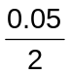 = 0.025 mol dm⁻³
K_{c} = 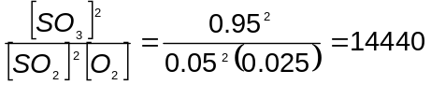mol⁻¹ dm³

(c) (i) Substitution.

(ii) Compound Y has a high boiling point because it is giant
ionic and requires a lot of energy to break the strong electrostatic forces of attraction between the oppositely charged ion.
Compound Y is soluble in water because it can form ion-dipole interaction with the molecules of water. [Total: 20]
6(a)
H
⎢
⎯C ⎯ O ⎯ C ⎯ CH₃
⎢ ⎢⎢
CH₃ O
A
H
⎢
C ⎯ OH
⎢
CH₃
B

C = O
⎢
CH₃
D

CH₃CO₂H
C

C = N ⎯ N ⎯
⎢ ⎢
CH₃ H

E
NO₂
NO₂

Equation:
H
⎢
⎯C ⎯ O ⎯ C ⎯ CH₃
⎢ ⎢⎢
CH₃ O
H
⎢
C ⎯ OH + CH₃CO₂H
⎢
CH₃

+ H₂O →

- A has a benzene ring as C:H ratio is almost 1:1.
- A neutral liquid A, C₁₀H₁₂O₂ when heated with aqueous hydrochloric acid gave two products, B and C.
→ A undergoes acid hydrolysis to form B and C.

- B gave a yellow precipitate when warmed with aqueous alkaline iodine.
→ B has –CH₃CH(OH) structure.

- When heated with acidified sodium dichoromate (VI), B gave D, C₈H₈O.
→ B undergoes oxidation to form a ketone, D.

- D reacts with 2,4-dinitrophenylhydrazine to give orange crystals, E.
→ D is a ketone.

(b) (i) S₂O₈²⁻ and I⁻ will repel each other/ No catalyst is added.

- Using experiments 1 and 3,
When the concentration of I⁻ increased by 1.5 times, the rate increased by 1.5 times. 1st order with respect to I⁻.

Using experiments 2 and 3,
When concentration of S₂O₈²⁻ is halved, the rate is halved. 1st order with respect to S₂O₈²⁻.

- Rate k[I⁻][S₂O₈²⁻]
(c) Al³⁺ has a high charge density, hence when AlCl₃ dissolves in water, the surrounding water molecules in the hydrated Al³⁺ ion is polarised. The O-H bond in water is polarised and H⁺ is easily liberated.
AlCl₃(s) + 6H₂O → [Al(H₂O)₅(OH)]²⁺(aq)+ H⁺(aq) + 3Cl–(aq)
(Equation without Cl⁻ is accepted.)

PCl₃ is covalent and it dissolves vigorously in water to give an acidic solution with the evolution of HCl gas.
PCl₃ + 3H₂O → H₃PO₃ + 3HCl

(d) (i) Acidic. (Se is below S in the periodic table so SeO₂ is expected to behave similarly to SO₂, which is acidic.)
(ii) SeO₂ + 2OH⁻ → SeO₃²⁻ + H₂O
(iii) Bent / V-shaped / non-linear
[Total: 20]

H
C = C
H
CO₂H
H
C = C
CO₂H
H
7(a) (i)

CH=CHC ⎯ O ⎯ CH₃
⎢⎢
O
(ii)

(iii) sp³

(iv) C₆H₅CH₂CH₂CH₂OH < C₆H₅CH₂CH₂CO₂H < X (or C₆H₅CH₂CHClCO₂H
X is more acidic due to the presence of electron-withdrawing Cl in X [1].
This caused the O-H bond in X to be more polarised. The O-H bond is weakened, hence the H+ is lost easier.

(v) Test: Add NaOH(aq) to X and Y and heat. Then cool the products. Acidify the products with HNO₃(aq). Add AgNO₃(aq).

Observation: X will give a white precipitate (AgCl) and Y will give a yellow precipitate (or Y will not give a white precipitate).

(b) (i) K_{w} = [H⁺ (aq)] [OH⁻ (aq)] mol² dm⁻⁶
(ii) Neutralisation
(iii) Exothermic because bonds are formed when water is formed.

(iv) Because [H⁺] and [OH⁻] are still equal.
(v) pH at 62ºC = 6.54. So, [H⁺] = 10^{-6.54} = 2.88 x 10⁻⁷ mol dm⁻³.
K_{w} = [H⁺ (aq)] [OH⁻ (aq)] = (2.88 x 10⁻⁷)² = 8.32 x 10⁻¹⁴
(vi) Total [H⁺] = 2.88 x 10⁻⁷ + 1 x 10⁻⁸ = 2.98 x 10⁻⁷ pH = -lg (2.98 x 10⁻⁷) = 6.53

(c) “Free” H⁺ ions in an aqueous environment form H₃O⁺ with water molecules.

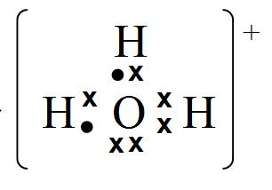
(i)

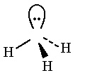
O
+
(ii)

[Total: 20]

